**COMMODITY INTELLIGENCE SYSTEM**

**ABSTRACT**

Commodity Intelligence System is a Portal providing as complete solution for the commodity class which envisage a very user-friendly platform for all classes which are based on commodity transactions by providing a service for every one interested in picking up commodity prices and also for pursuing the trading on-line. It is a unique concept of networking all major national trading centers and market yards across the country providing regularly updated online information about commodity prices at any particular point of time along with all structured reports vis.. trends and projections daily, weekly, monthly, yearly which are the ready for all classes requiring information on commodities

The main purpose of commodity intelligence system is essentially to collect the latest fluctuating prices of commodities available and required in the market at a particular given point of time and at particular specified market locations. So that the producer, trader, consumers can get best deal out of their all commodity deals and derive reasonable profit in all levels.

**SYSTEM SPECIFICATION**

**HARDWARE SPECFICATION**

* Processor : P 4 700 GHz.
* RAM : 4 GB RAM
* Hard Disk Drive : 180 GB

**SOFTWARE SPECIFICATION**

* Operating System : Windows 7/8/10
* Front End : JAVA
* Back End : SQL

**MODULES**

1. **Product Registration**

Commodity owner has registered the product details in this module. In this module will used to search and find the details as category wise.

1. **Customer Registration**

This module collects all the information about the customer, when customer billed first time, we just collect the information for the future purpose.

1. **Purchase Management:**

when the manager purchasing the products or material, they should register this purchase module. It’s managed by shop owner then collect the information about the product details and price etc… After the purchasing only should sales the product.

1. **Sales Management**

This module calling when the customer has to be purchased and before billing. It will show the all the details about the product. Which is basically used to find the stock entry details. A sales module collects the customer information so we can contact the customer easily.

1. **Stock Details**

This Stock module will be helps to find the what are all the products are available in shop and how many products are in stock also we can check. No need to manually count a check and verify the product. Systematically it will calculate and give a report.

1. **Billing Management**

This module shows a billing detail, what are the items are sales in date wise and how much are they gain. Total entire application will be showing in this module.

**Data Flow Diagram / USE Case Diagram**

**LEVEL 0**

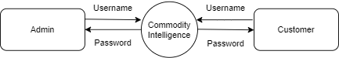

**Level 1**

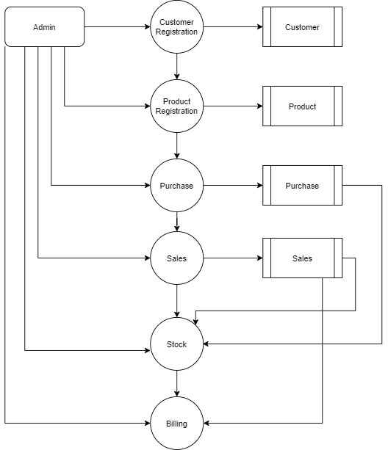

**ER Diagram**

